The Music for Galway CELLISSIMO Ambassador Programme

The Galway Cello is a unique instrument, fashioned by luthier Kuros Torkzadeh for the cello festival Cellissimo from woods mainly grown in Co. Galway. Its most distinguished feature is the emblematic Claddagh Ring on its scroll, making it unmistakably Galway. Catherine Cotter was the first Cellissimo Ambassador from 2021-24: Music for Galway will give it on loan to a talented Irish based young cellist. This cellist will be selected in live auditions during Cellissimo 2024 in Galway on Monday 20th May, 2024 and will become Cellissimo Ambassador until the third edition of the festival in 2027. See www.cellissimo.ie for more information on the festival itself.
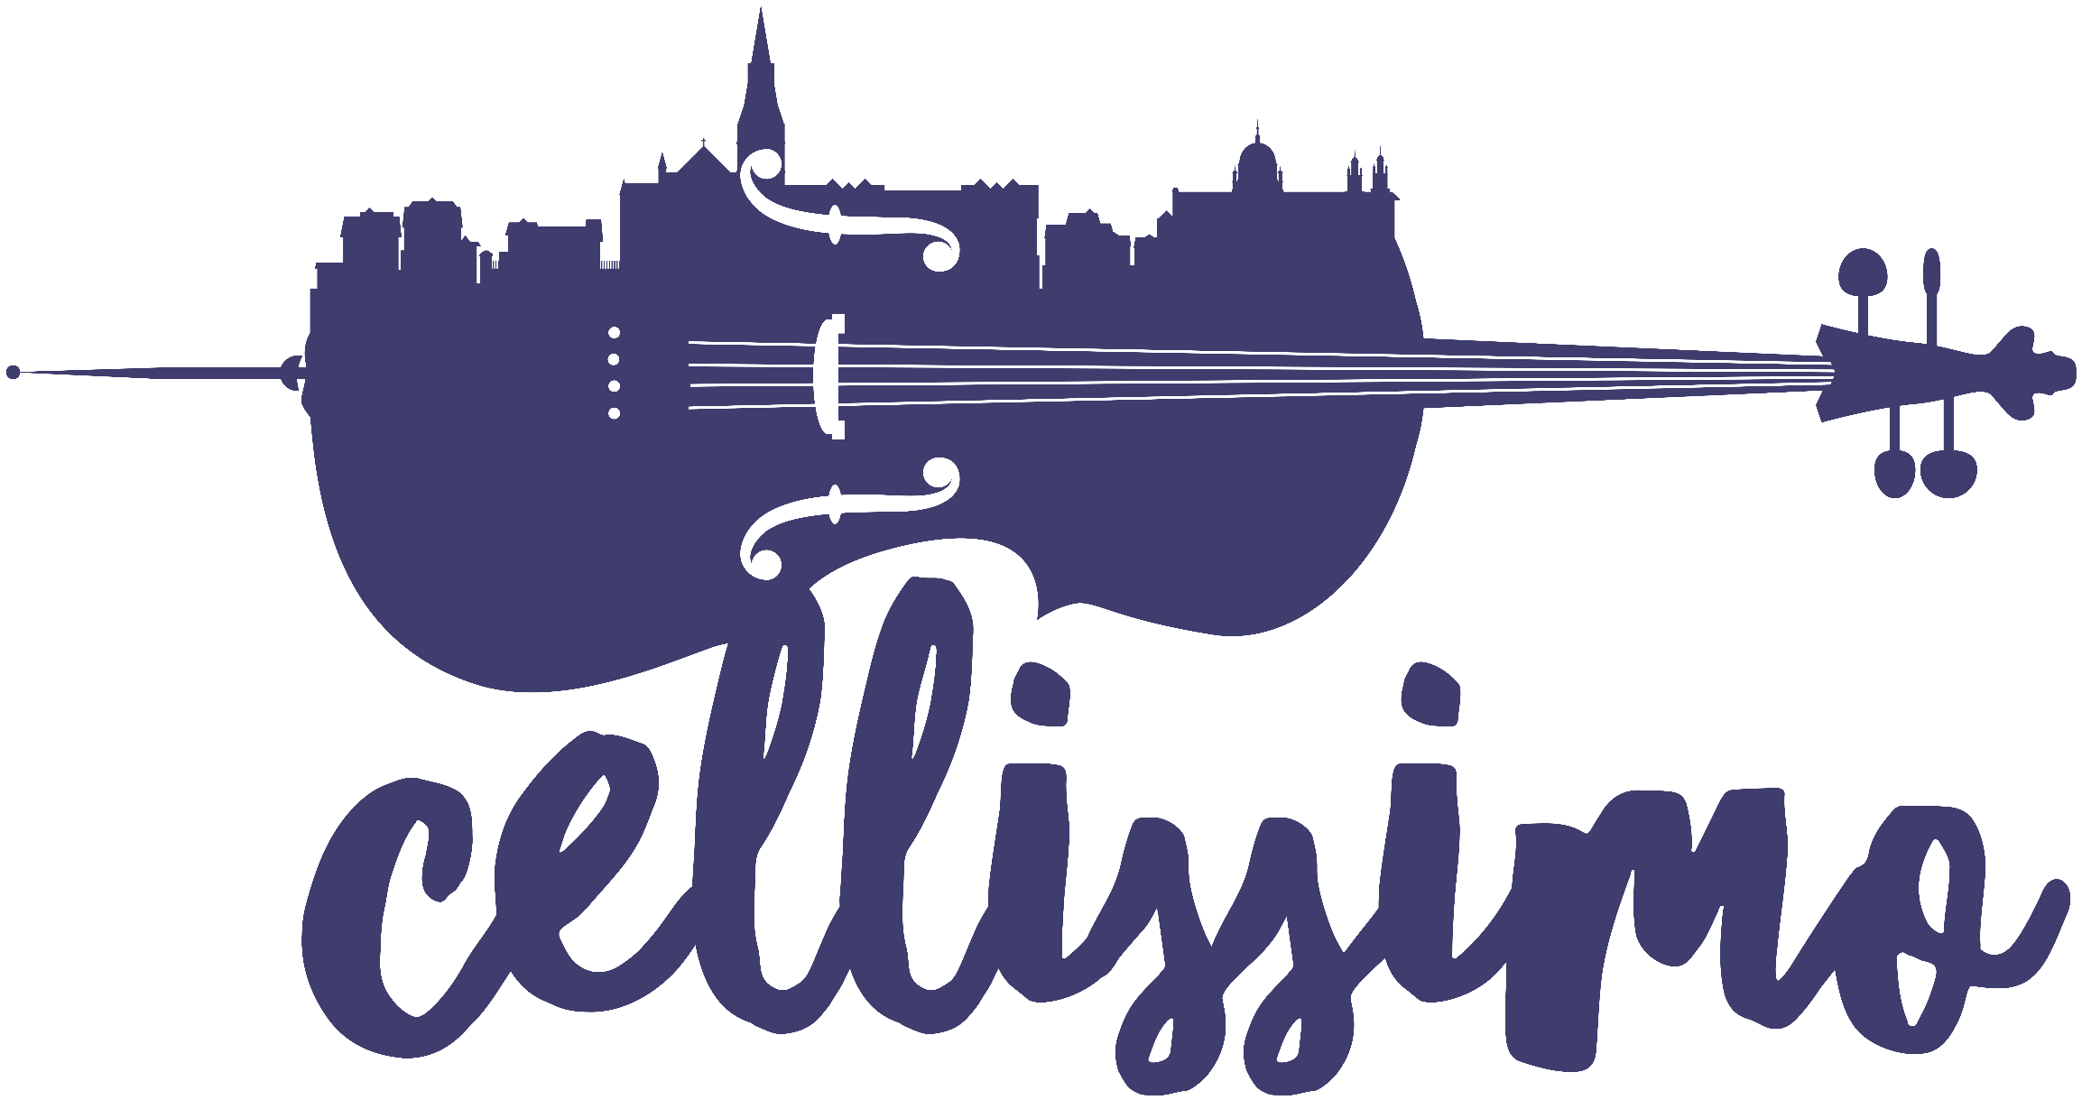
Aims of the programme:

- To give life to the Galway Cello and to ensure that it is played regularly
- To help in the professional development of a young cellist by giving them the use of a valuable handcrafted instrument
- To further the professional development of a young cellist by offering performance opportunities
- To use both cellist and instrument as ambassadors for the next edition of Cellissimo in 2027

The chosen CELLISSIMO Ambassador:

- Is aiming to become / is already pursuing a career as a professional cellist
- Uses the Galway Cello as their primary instrument
- Mentions the Galway Cello and their role as Cellissimo Ambassador in their biography
- Agrees to appear in Galway for a maximum of three engagements per year for which they will be paid performance fees but no expenses
- Is willing to be active on social media and post either in the voice of the Galway Cello OR about their life with the instrument
Instagram: @the_cello_ambassador | Twitter (X): @CelloAmbassador
- Understands the value of this unique instrument and ensures its safety
- Will cover insurance costs
- Is between 18 and 26 years old at the time of selection in May 2024

See the making of the Galway Cello: https://youtu.be/wFeUNw9y9ho
Adrian Mantu performs Giovanni Sollima’s Lamentatio on the Galway Cello: https://musicforgalway.ie/exhibition-adrian-mantu/

Interested cellists can arrange for a try-out of the instrument. Contact isp@musicforgalway.ie to make arrangements.

Approx. three cellists will be selected to audition in front of a live audience at the Town Hall Theatre in Galway on May 20th 2024. To apply, please fill out the application form below. You will be expected to perform one movement of a Bach Suite and a short piece for cello and piano of your choice. You will be accompanied by pianist Dearbhla Brosnan. The performance should have a total duration of no more than 15 minutes and there will also be a 10-minute interview with the selection panel earlier on the the day.

Galway Cello Cellissimo Ambassador | APPLICATION FORM

Name: __________________________________________________________

Address: ________________________________________________________

Email: _______________________________ Mobile: _____________________

Date of Birth: _____________________________

Please select:
- Male
- Female
- Prefer not to say

Name of Music College / Conservatoire that you are attending/have attended:
________________________________________________________________

Current year/ level of study achieved: ______________________________

TO COMPLETE:
Please complete this question: “Why I want to be the Cellissimo Ambassador and have the loan of the Galway Cello until 2027.”
(max 300 words) (Word document or PDF)

TO INCLUDE:
Link to a solo (or duo) performance video (YouTube / Vimeo / Dropbox) – two contrasting pieces.
CV - One page max (Word document or PDF)
Your proposed programme for the live auditions (Bach movement plus cello/piano piece - total maximum duration 15 minutes - Word document or PDF)

Send all items in one email to: isp@musicforgalway.ie by Friday 4th of April 2024.

For any further information or assistance contact isp@musicforgalway.ie
Selection panel: Finghin Collins, Anna Lardi, Jane Cords O’Hara
See www.cellissimo.ie for festival programme - Cellissimo May 18th – 26th 2024

In accordance with GDPR, Music for Galway will retain your information for the duration of this project only.

